**COMPUTER NETWORKS 2**

**Project Report On**

**FFMPEG TRANSCODING**

Index

1. Introduction
2. Software component details
3. Implementation and Screen shots
4. Result Analysis
5. References
6. **INTRODUCTION**

Problem Statement

The video streaming over enough bandwidth network deliver good good quality of video.But when the link is congested and bandwidth is not enough to transmit all the video packets, the delivered video quality is worse. Here the goal is to perform transcoding to let the bandwidth requirement for video streaming become less. Then the delivered video quality may not be good, but can still be acceptable.

Objectives

* Compress the yuv format video file and output the file in mpegts format.
* Run the topology with enough bandwidth and also without enough bandwidth.
* Transmit all the frame from mpegts file to another mpegts file.
* Decompress the newly obtained mpegts file to yuv format.
* Compare the received video with original video to obtain PSNR value to check quality.

**TRANSCODING :** It is a process of converting an audio or video file from one encoding format to another in order to increase the number of compatible target device a media file can be played on . In other words it is the process of exporting digital video into a particular format.

**There are three types of Transcoding**

1. **Lossy-to-lossy**: This is the least ideal form of transcoding. It means you already have a file with decreased quality and transcoding causes the quality to degrade even further. The only reason to use this form of transcoding is to lower the bitrate and save storage space on portable players.
2. **Lossless-to-lossless**: By taking advantage of better compression and hardware support a file can be losslessly compressed. This type of transcoding is useful for converting to new formats without losing quality, but the resulting files are often too large to send to portable devices.
3. **Lossless-to-lossy**: This transcoding method causes less quality loss than lossy-to-lossy and produces file sizes small enough for portable devices. You must maintain archives of losslessly compressed files to truly leverage this transcoding method.

**EXAMPLE OF TRANSCODING**

The world’s largest provider of user-generated videos, YouTube, receives over 300 hours of uploads every minute—and it uses transcoding to make those videos available in 5+ different qualities and 5+ different formats. This means the original uploaded content can be transcoded into over 20 versions. YouTube kicks off the encoding and transcoding process as soon as the original upload is complete, which is why new videos are often only available in low-resolution until the higher-res videos are transcoded.

**FFMPEG :**

* FFmpeg is a collection of different projects for handling multimedia files. It's often used behind the scenes in many other media-related projects.
* It is used to convert different file formats and codecs.
* It is used check the quality of video formats
* It is used for resizing ,compressing,decompressing the video formats.

1. **Software Components**

* Ubuntu O.S
* FFMPEG

1. **IMPLEMENTATION**

**TEST CASE 1 :** When there is enough bandwidth ,so that quality of video is good.

Step 1 : Run topology script

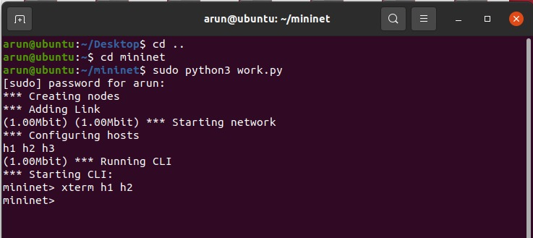

Here we can see the enough bandwidth is 1mbps

Step 2 : Open xterminal h1 and h2 , H1 - sender , H2 - Reciever

H1- sender , Here we are sending mpegts file I.e abc.ts to reciever H2

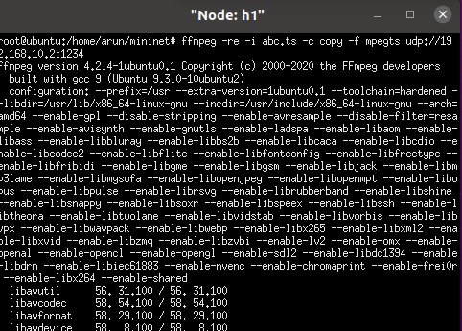

H2 - Reciever

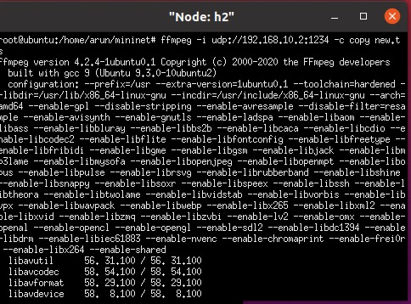

Here , we can see that new.ts file gets all the frames that is sent by h1 sender

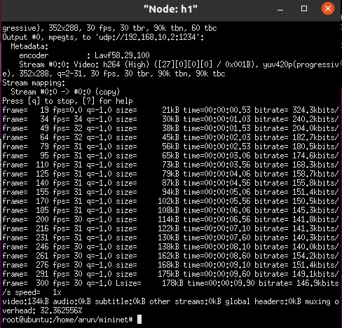

Here , the frame is been sent to new.ts file in h2 reciever

Step 3 : After recieving the frames compress the newly obtained mpegts file to yuv format in H2- Reciever

And also calculate the PSNR(peak signal noise ratio) to check quality

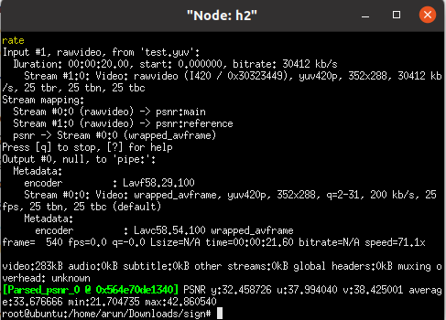

Here , we can see the average PSNR value is 33.6766 . So the quality is good for enough bandwidth.

**TEST CASE 2 :** When the link is congested and there is no enough bandwidth to transmit all the frames . The quality may get bit worse. PSNR value may decrease bit

Step 1 : Run topology script

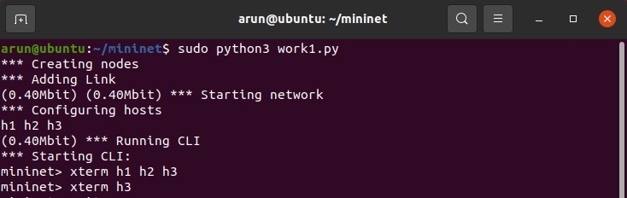

Here we can see the enough bandwidth is 0.40mbps

Step 2 : Open xterminal h1 and h2 , H1 - sender , H2 - Reciever

H1- sender , Here we are sending mpegts file I.e abc.ts to reciever H2



H2 - Reciever



Here , we can see that new.ts file gets all the frames that is sent by h1 sender



Here , the frame is been sent to new.ts file in h2 reciever

Step 3 : After recieving the frames compress the newly obtained mpegts file to yuv format in H2- Reciever

And also calculate the PSNR(peak signal noise ratio) to check quality

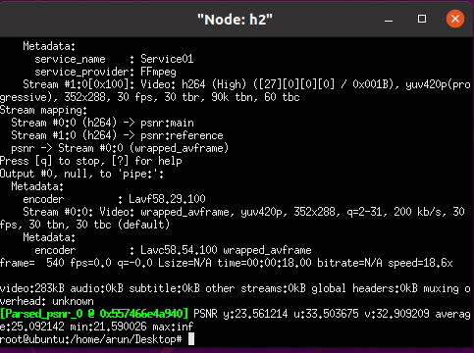

Here , we can see the PSNR value is getting decreased(Average PSNR).

**TEST CASE 3:** So in test case 2 there is no enough bandwidth therefore the PSNR value decreased bit. Here we can use transcoding process to let the bandwidth requirement for video streaming become less.Then the delivered quality may be acceptable.

Step 1 : Run topology script



Here we can see the enough bandwidth is 0.40mbps

Step 2 : Open xterminal h1 and h2 , H1 - sender , H2 - Reciever, H3- Transcoding

H1- sender , Here we are sending mpegts file I.e abc.ts to reciever H2



H2 - Reciever



Here , we can see that new.ts file gets all the frames that is sent by h1 sender



Here , the frame is been sent to new.ts file in h2 reciever

Step 3 : After recieving the frames compress the newly obtained mpegts file to yuv format in H2- Reciever

And also calculate the PSNR(peak signal noise ratio) to check quality

C:\Users\Darshan LP\Desktop\H3.png

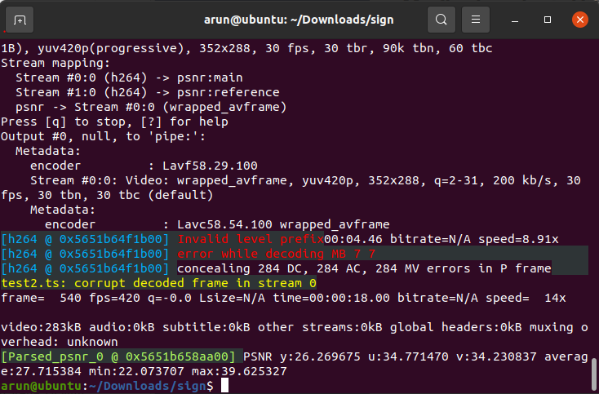

Here , we can see the average PSNR value is 27.715384 . So the quality is good for enough bandwidth.

1. **RESULT ANALYSIS**

* When there was enough bandwidth we were getting the quality of video good ie PSNR value was good enough.
* When the bandwidth was reduced the PSNR value of video decreased bit ie the all the frames where not transfered. So the quality was little worse.
* When we used transcoding for same bandwidth which was reduced we were able to get same video quality as when we used enough bandwidth ie video quality was not reduced. We were getting good PSNR values.

**DEMONSTRATION VIDEO :**

[**https://drive.google.com/file/d/1uDtkPv7rec-vbprW8O-JXJkye6G4RVgL/view?usp=sharing**](https://drive.google.com/file/d/1uDtkPv7rec-vbprW8O-JXJkye6G4RVgL/view?usp=sharing)

**REFERENCES**

1. <http://csie.nqu.edu.tw/smallko/sdn/ffmpeg_transcoding.htm>
2. <https://www.wowza.com/blog/what-is-transcoding-and-why-its-critical-for-streaming>.
3. <https://opensource.com/article/17/6/ffmpeg-convert-media-file-formats>
4. <https://medium.com/abraia/video-transcoding-and-optimization-for-web-with-ffmpeg-made-easy-511635214df0>
5. <https://developer.nvidia.com/blog/nvidia-ffmpeg-transcoding-guide/>